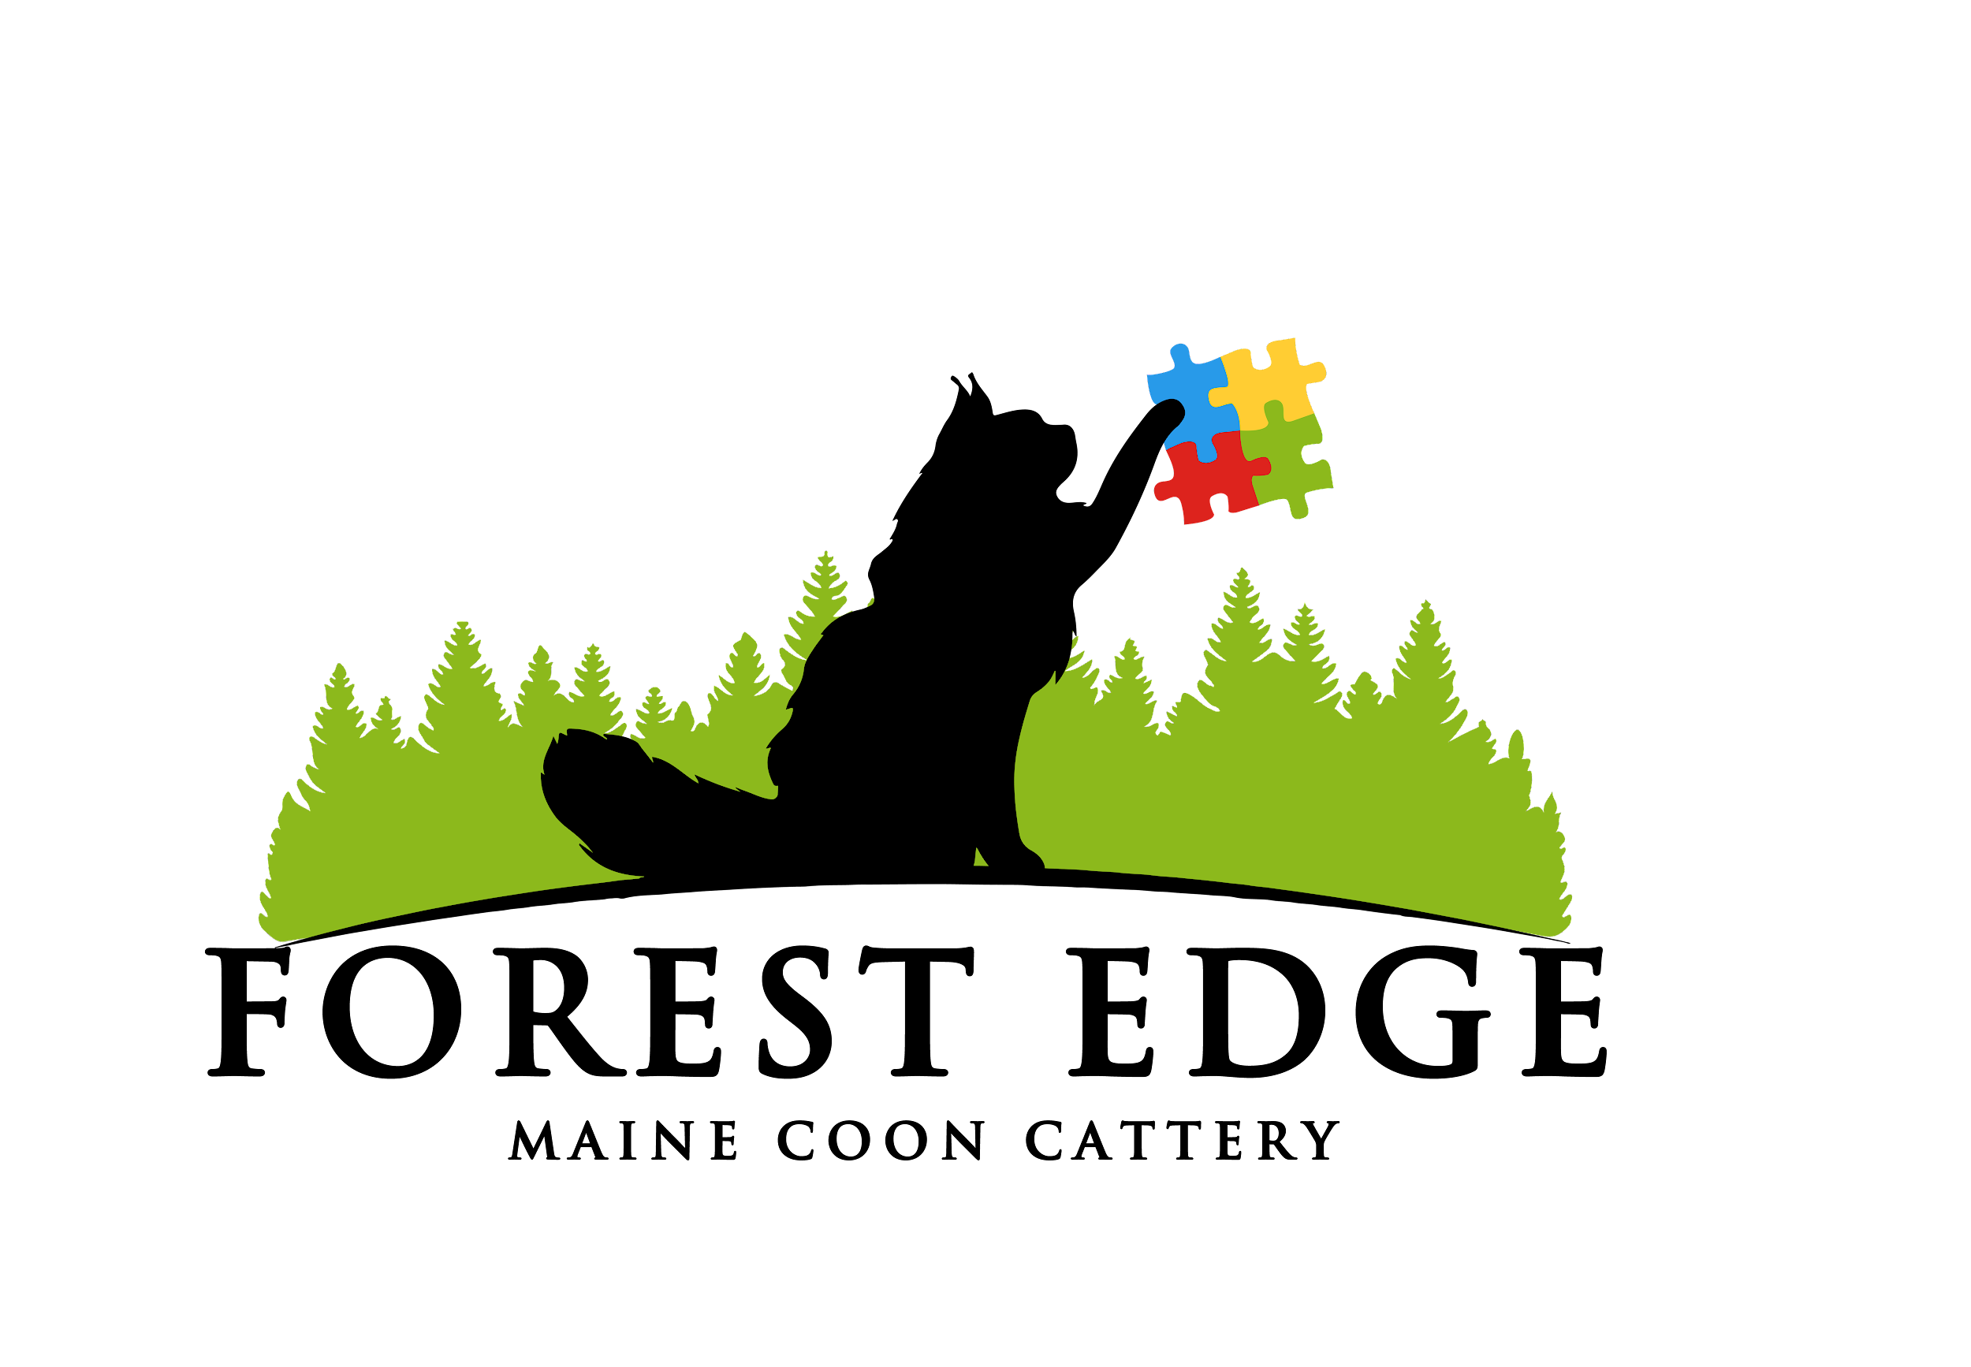

Forest Edge Maine Coons

**Kitten Application**

Name: Date:

1. Why do you want a Maine Coon?
2. On a scale of 1 to 10, how important is it to you to have an XXL cat? ____ We do NOT breed for size and can’t guarantee the size a kitten will grow to be.
3. Is this cat/kitten a gift for someone living outside of your home? If so, who?
4. Do you have any other pets in the home? If so, what kind and how many? If you have a dog, are they cat friendly?
5. Will this cat be allowed outdoors? If you currently have cats do they go outdoors? If so please explain.
6. Are you wanting a pet or are you interested in breeding?
7. How do you feel about declawing cats?
8. Are there any kids in the home under the age of 8? (This is just to help match you up with the appropriate kitten)
9. Do you have a vet?
10. If for any time or reason during your cat’s life you can’t keep it, would you be willing to return him/her to the breeder?
11. Please list the top colors that you will consider for your future kitten.

1.)

2.)

3.)

4.)

If you choose all white, would you consider a deaf kitten? _________

11. Please list the colors that you would NOT want for your future kitten.

1.)

2.)

3.)

12. Please list the gender(s) you would like.

Thank you for your time! Please email your application to [forestedgecats2@gmail.com](mailto:forestedgecats2@gmail.com) . We will review your application and contact you with further information only if your application is approved.

It is a $200 nonrefundable deposit to get on our wait list. This does go towards the purchase price. Kittens will be offered in order of application date.

When you reserve your kitten there will be an additional $200 deposit, this also goes toward the balance.

Male kittens are $2000, females are $1800. Pale silver and smokes will be $2000 to $2500. All kittens leave at 13 to 16 weeks with the first set of shots, health exam, contract, registration and are spayed or neutered.

Kittens will be paid in cash or cashier’s check only at pick up.

Angie Moore

Forest Edge Maine Coons